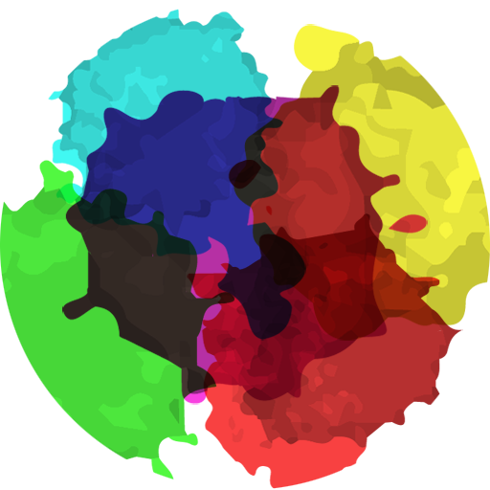

2D Splatter Effect

Thanks for downloading my asset , I hope you like it. For any query contact me at [madfireongames@gmail.com](mailto:madfireongames@gmail.com)

Important Things

The splatter effect has 2 shaders which are responsible for the splatter effect.

1. Splatter – this is the shader used by the splatter effect.
2. Surface – this is the shader used by the surface on which splatter effect has to spawn.

Important scripts

Splatter:- This script controls the object which show the splatter effect.

How to get Splatter effect

“Splatter” object must have splatter material on it and not the unity default material. The splatter material has splatter shader on it. Assign the sprites, etc as shown below.

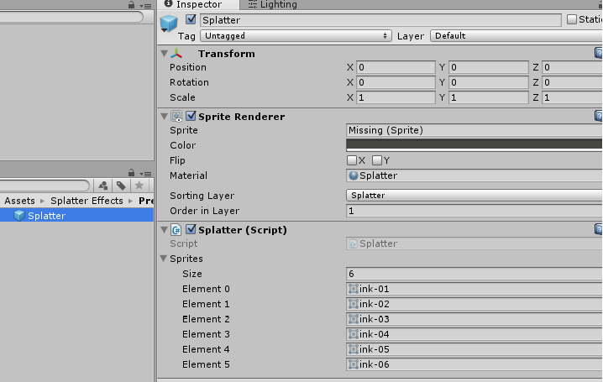

“Surface” on which the splatter is going to spawn must have surface material and not the unity default material.

